FEATURES OF THE QUADTRO SELECT CUSHION
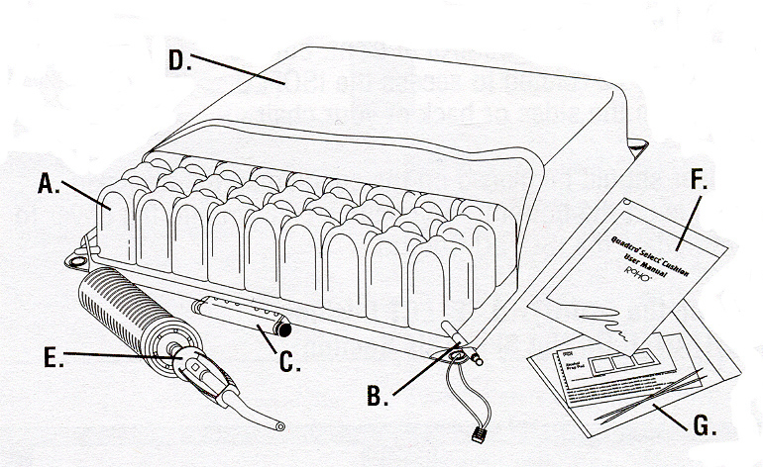

- Cells: The individual air pockets / bubbles are called “cells”.

- Valve: the valve is used to adjust the amount of air in the cushion. The valve should NOT be used for lifting or carrying the cushion.

- ISOFLO Control: this Control allows the user to direct the air distribution in the cushion for positioning and stability.

- Two-way stretch, breathable cover: the cushion cover protects the cushion and allows for an optimal degree of therapeutic value.

- ROHO Pump: The ROHO Pump is used to inflate the cushion.

- User Manual: Each ROHO Cushion includes a User Manual that provides instruction on adjustment, care, repairs and warranty.

- Patch Kit: A Patch Kit is included to repair small holes in the cushion.

Steps to properly adjust the ROHO cushion

The Cushion should be placed on the wheelchair seat with the cells pointing upward. The ISOFLO Control should, preferably, be placed in front, but can be used from the sides or back of the wheelchair as well. The cover should be placed on the cushion so that the non-skid material is at the bottom (there is an opening in the cover for the ISOFLO Control).

Proper adjustment or verification of the air pressure can only be done while the user is sitting in the cushion. The object of the adjustment procedure is to “immerse” the user as deeply as possible in the cushion without bottoming out. Deep immersion is achieved by having as little internal air pressure in the cushion as possible without allowing any part of the body, especially the bony prominences, to touch the base of the cushion.

Adjust the Quadtro Select cushion using the following procedure:

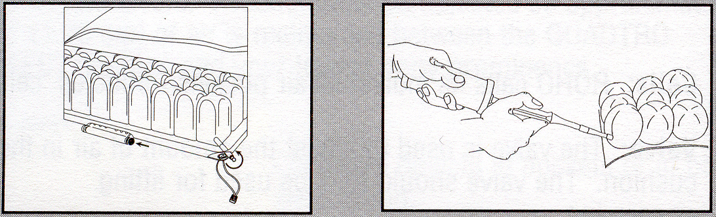
Step 1 Step 2

Step 1: Open the air value by twisting it counter-clockwise. Check that the ISOFLO Control’s green knob is pushed toward the centre, in the UNLOCKED position.

Step 2: Attach the rubber hose on the ROHO Pump to the end of the valve. Inflate the cushion with the pump until just before the cushion begins to arch.

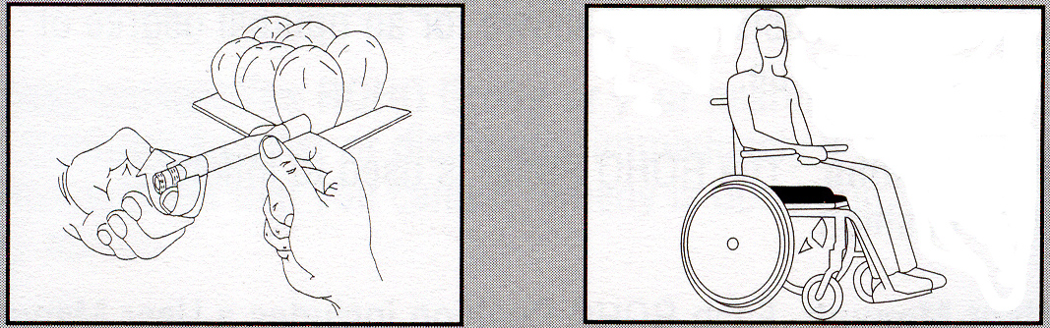
Step 3 Step 4

Step 3: Remove the pump hose from the valve and close the valve by twisting it clockwise.

Step 4: Sit on the Quadtro Select cushion with the armrests and footrests of the wheelchair properly placed.

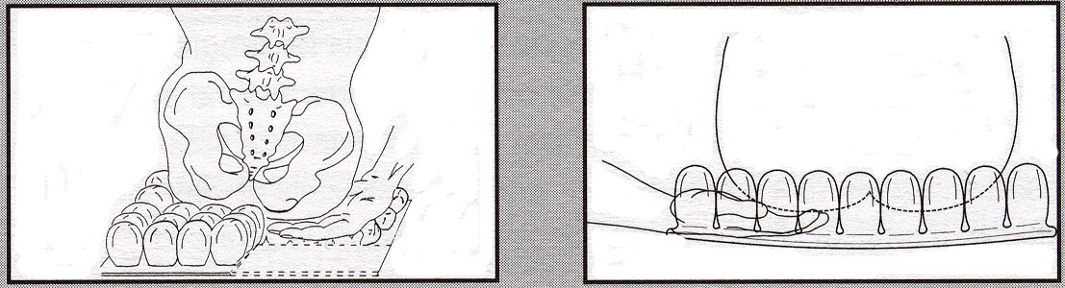
Step 5 Step 6

Step 5: Slide your hand beneath your buttocks to locate your lowest bony prominence. If necessary, your carer should assist you with this step.

Step 6: Leaving one hand in place beneath the lowest bony prominence, use the other hand to open the valve. As air is released from the cushion, you will begin to sink into it. When your fingertips touch the base, close the valve. Approximately ½” or 1.25 cm of air should be between your lowest bony prominence and the base of the cushion.

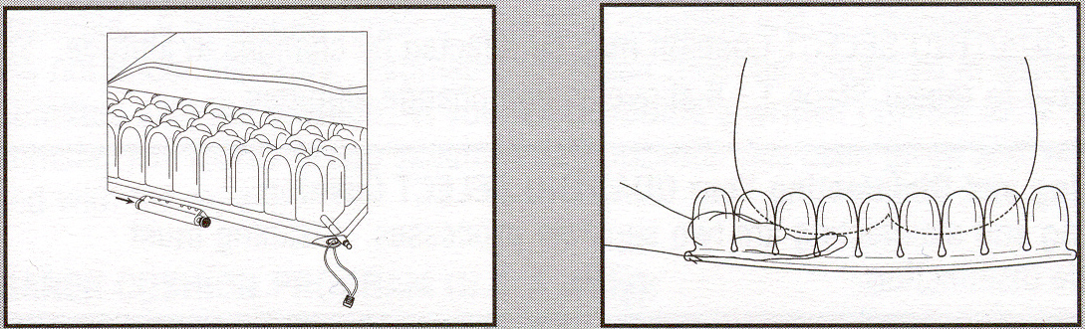
Step 7 Step 8

Step 7: Position yourself on the cushion in the posture you want to maintain. Allow the air to transfer to accommodate your position. Once you are properly positioned, push the ISOFLO Control’s red knob toward the centre, in the LOCKED position.

Step 8: Check your immersion by sliding your hand under your lowest bony prominence to ensure you have not bottomed out.

Note:
If any part of your body is touching the cushion base, too much air has been released and the therapeutic value of the cushion will be lost. To fix, repeat the entire procedure.

Do not over-inflate. Too much air in the cushion will reduce the therapeutic value of the cushion and could result in skin tissue breakdown or unstable seating position.

Be sure to check the cushion daily to ensure that you have not “bottomed out” or over-inflated the cushion and that the cushion is adjusted correctly.

If you wish to change your positioning for various activities, UNLOCK the ISOFLO Control by pushing the green knob toward the centre and repeat Steps 7 and 8.

Cleaning Instructions

Deflate the cushion, close the valve, and place the cushion in a large sink. Gently scrub the air cells and spaces between them with a soft plastic bristle brush, sponge or washcloth. Use a liquid dishwashing or laundry detergent or other general-purpose cleaning product.

To clean the cover, remove it from the cushion and machine wash it using a COLD wash cycle and a liquid laundry detergent or other general purpose cleaning product. Air dry. Do not use heat or bleach.

To disinfect the cushion, use a solution of ½ cup liquid household bleach per quart of water (125 ml of bleach to 1 litre of water). Keep the clean cushion wet with bleach solution for 10 minutes. Rinse thoroughly, and dry.

Do not use oil-based lotions, or phenolic-based disinfectants on your cushion as they may compromise the integrity of the rubber.

Special Instructions

Only after adjustment is made for the lowest bony prominence, should other compartments be adjusted for comfort or for positioning needs.

Protect your cushion from pins and other sharp objects and exposure to hot cigarette ashes. If your QUADTRO Cushion is punctured, you can repair it using the Patch Kit – follow the instructions in the Kit.

WARNING
Never use the ISOFLO Control Valve as a handle. Pulling on the valve mechanism may cause it to leak air. Always follow these simple procedures.
- When necessary, use the handle strap on your cushion cover as a handle
- Check your cushion for proper inflation at least daily.

Always consult appropriate therapist regarding safety and usage of this equipment.
If you experience problems with equipment on loan from MND Victoria, please contact us immediately on (03) 9830 2122

